**The Random CAT API**

**Resources**

Allows you to receive a paginated response of random cat images

**Resource URL**

/t/blazeclan/randomcatimage/v1

**Security Access**

API required to access the API which can be obtained from…

**Methods**

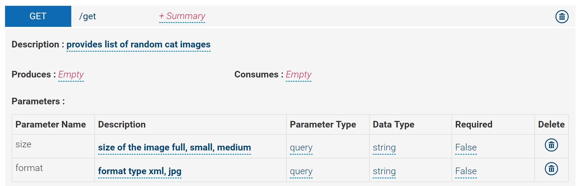

**Parameters**

| **Name** | **Values** | **Required** | **Description** | **Default** |
| --- | --- | --- | --- | --- |
| api_key | [apply for one](http://thecatapi.com/api-key-registration.html) | No | Passing this gives you access to all the images, voting, favouriting, uploading etc | *none* |
| format | xml / html / src | No | The output format, as XML, an HTML img tag, or the src to use in an img tag. | src |
| size | small, med, full | No | Size of returned Images, small = 250x, med = 500x, full = original size. | full |

**Example Request:**This'll return you xml data for 20 random cats.

<http://t/blazeclan/randomcatimage/v1/get?format=xml>

**Example Response**

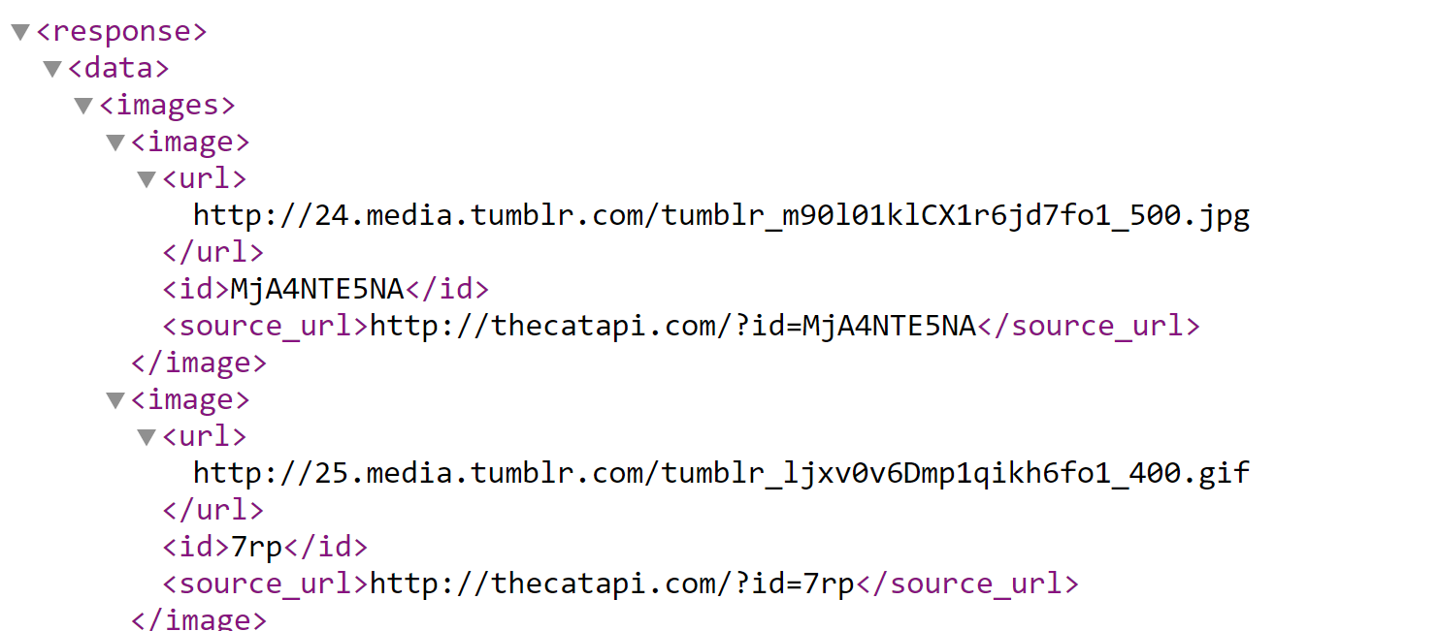

**Status and Error Codes**

200 Success

401 Unauthorized

400 Bad request

404 Not found